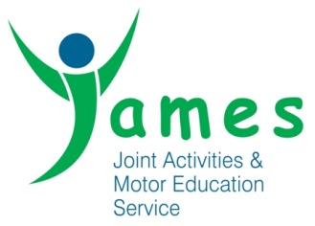
Managing Allegations of Abuse against Staff Policy
Introduction
It is essential that any allegation of abuse made against a member of staff, students on placement or volunteers in our setting are dealt with fairly, quickly, and consistently, in a way that provides effective protection for the child/ young person and at the same time supports the person who is the subject of the allegation. The procedures outlined in this policy will be followed alongside the complaints procedure and JAMES Safeguarding documentation.
All staff and volunteers should understand what to do if they receive an allegation against another member of staff or they themselves have concerns about the behaviour of another member of staff. It is our policy that all allegations will be reported straight away, to the Operations Manager; Kevin Metcalfe (kevin.metcalfe@jamesuk.org or 01274-483075).
If an allegation is made about the Operations Manager, this must be brought immediately to the attention of the JAMES chair of trustees; Ros Seton – 01274 483075
The person named above receiving the allegation must follow the allegations flow chart from the Bradford Partnership – Working Together to Safeguarding Children; as part of the investigation into the allegation.
This policy follows the Government guidance;
- ‘Safeguarding Children and Safer Recruitment in Education.
- Working Together to Safeguard Children: A guide to inter-agency working to safeguard and promote the welfare of children” (updated July 2023).
Purpose
This policy will be adopted in respect of allegations that might indicate that a person is unsuitable to continue to work with children/ young people/ vulnerable service users in their present position, or in any capacity. JAMES complaints and Safeguarding documentation will be followed alongside this policy (where both can be found on the JAMES intranet).
This policy will be used in respect of all cases in which it is alleged that a member of staff (including a volunteer, student) has:
• behaved in a way that has harmed a child/ young person/ service user, or may have harmed a child/ young person/ service user;
• possibly committed a criminal offence against or related to a child/ young person/ service user; or
• behaved towards a child/ young person/ service user or users, in a way that indicates they are unsuitable to work with children/ young people/ service users. This will include cases of verbal abuse.
There may be up to 3 strands in the consideration of an allegation:
• a police investigation of a possible criminal offence;
• enquiries and assessment by children’s social care about whether a child/ young person is in need of protection, or in need of services;
• consideration by JAMES of disciplinary action in respect of the individual.
Supporting Those Involved
Parents or carers of a child or children/ young person involved will be told about the allegation as soon as possible if they do not already know of it. They will also be kept informed about the progress of the case and told the outcome where there is not a criminal prosecution. That includes the outcome of any disciplinary process. NB. The deliberations of a disciplinary hearing, and the information taken into account in reaching a decision, cannot normally be disclosed, but the parents or carers of the child/ young person will be told the outcome.
In cases where a child/ young person may have suffered significant harm, or there may be a criminal prosecution, children’s social care, or the police as appropriate, the Operations Manager will also keep the person who is the subject of the allegations informed of the progress of the case and consider what other support is appropriate for the individual. If the person is suspended, the manager will also keep the individual informed about developments at JAMES. The person will be notified that they can instruct a representative specialist advice/ support where they require.
Confidentiality
Every effort will be made to maintain confidentiality and guard against publicity while an allegation is being investigated/considered.
Resignations and “Compromise Agreements”
The fact that a person tenders their resignation, or ceases to provide their services, will not prevent an allegation being followed up in accordance with these procedures. Every effort will be made to reach a conclusion in all cases of allegations, bearing in mind the safety or welfare of children/ young people including any in which the person concerned refuses to cooperate with the process.
Wherever possible the person will be given a full opportunity to answer the allegation and make representations about it. The process of investigating the allegation, and reaching a judgement about whether it can be regarded as substantiated will continue even if the person does not cooperate.
Similarly, so called “compromise agreements” by which a person agrees to resign, JAMES agrees not to pursue disciplinary action, and both parties agree a form of words to be used in any future reference, will not be used in cases of alleged child abuse. In any event, such an agreement will not prevent a thorough police investigation where that is appropriate. Furthermore, it will not override the statutory duty to make a referral to the Disclosure & Barring Service (DBS) for consideration of placing the person’s name on the Children’s Barred List where circumstances require that.
Record Keeping
A clear and comprehensive summary of any allegations made, details of how the allegation was followed up and resolved, and a note of any action taken and decisions reached, will be kept on a person’s confidential personnel file, and a copy provided to the person concerned. The purpose of the record is to enable accurate information to be given in response to any future request for a reference if the person has moved on.
It will provide clarification in cases where a future DBS Disclosure reveals information from the police about an allegation that did not result in a criminal conviction. In addition, it will help to prevent unnecessary re-investigation if, as sometimes happens, an allegation re-surfaces after a period of time. The record will be retained at least until the person has reached normal retirement age or for a period of 10 years from the date of the allegation, if that is longer (see JAMES Record Retention Policy).
Timescales
It is in everyone’s interest to resolve cases as quickly as possible consistent with a fair and thorough investigation. Every effort will be made to manage cases to avoid any unnecessary delay.
Initial Considerations
The Local Authority Designated Officer (LADO, Local Authority Designated Officer) should be informed, by the Operations Manager/ JAMES Chair of all allegations of abuse against staff on the same day, even where the police are contacted directly.
The Operations Manager/ JAMES Chair, will inform the accused person about the allegation as soon as possible after consulting the LADO. However, where a strategy discussion is needed, or where police or children’s social care need to be involved, the manger will not do that until those agencies have been consulted, and have agreed what information can be disclosed to the person. If the person is a member of a union or professional association s/he will be advised to contact the Disclosure & Barring Service (DBS) at the outset.
If the allegation is not demonstrably false or unfounded, and there is cause to suspect a child is suffering or is likely to suffer significant harm, a strategy discussion will be convened by the Operations Manager/ JAMES Chair, with the LADO (Local Authority Designated Officer) and other appropriate agencies, such as the police and social services.
In cases where a formal strategy discussion is not considered appropriate because the threshold of “significant harm” is not reached, but a police investigation might be needed, the manager will consult with the LADO, police and any other agencies involved with the child to evaluate the allegation and decide how it should be dealt with.
(NB. The police will be consulted about any case in which a criminal offence may have been committed.)
If the allegation is about physical contact, the strategy discussion or initial evaluation with the police will take account of the fact that staff are entitled to use reasonable force to control or restrain children in certain circumstances, including dealing with disruptive behaviour, under s.93 of the Education and Inspections Act 2006.
The LADO and the Operations Manager/ JAMES Chair may conclude that the complaint or allegation is such that it is clear that an investigation by police and/or enquiries by social care is not necessary. In these circumstances the options for JAMES depend on the nature and circumstances of the allegation and the evidence and information available, and will range from taking no further action to summary dismissal or a decision not to use the person’s services in future.
Suspension
Suspension will be considered in any case where there is cause to suspect a child/ young person/ vulnerable adult, is at risk of significant harm, or the allegation warrants investigation by the police, or is so serious that it might be grounds for dismissal. However, a person will not be suspended automatically, or without careful thought.
The power to suspend is vested in the Management Team and the Board of Governors. However, they will speak to the LADO who may canvass police/social care views about whether the accused member of staff needs to be suspended from contact with children/ young people, to inform JAMES consideration of suspension.
Action on Conclusion of a Case
If the allegation is substantiated and the person is dismissed or JAMES ceases to use the person’s services, or the person resigns or otherwise ceases to provide his/her services, the Operations Manager/ JAMES Chair will determine with the LADO whether a referral to the DBS (Disclosure & Barring Service) is required, or advisable. JAMES must report to the DBS (Disclosure & Barring Service), any person (whether employed, contracted or a volunteer) whose services are no longer used because they are considered unsuitable to work with children. This report will be made within one month of the decision to cease using the services of that person.
In cases where it is decided on the conclusion of the case that a person who has been suspended can return to work the nursery will consider how best to facilitate that. We appreciate that most people will benefit from some help and support to return to work after a very stressful experience. Depending on the individual’s circumstances, a phased return and/or the provision of a mentor to provide assistance and support in the short term may be appropriate. JAMES will also consider how the person’s contact with the child/ young person/ vulnerable adult, who made the allegation can best be managed if they are still attending.
Action in Respect of False Allegations
If an allegation is determined to be false, the Operations Manager/ JAMES Chair, will refer the matter to children’s social services to determine whether the child concerned is in need of services, or may have been abused by someone else. In the rare event that an allegation is shown to have been deliberately invented or malicious, the Operations Manager/ JAMES Chair will consider whether any disciplinary action is appropriate against the staff/child who made it, or the police should be asked to consider whether any action might be appropriate against the person responsible if they was not a child.
Local Authority Designated Officer (LADO)
Contact details:
Bradford Local Authority Designated Officer:
01274 435600 or LADO@bradford.gov.uk.
Safeguarding children is everybody’s responsibility. All staff members have a responsibility to report a concern if they believe a member of staff has behaved inappropriately towards a child.
All concerns should be escalated to DSO and/or the Local Authority Designated Officer (LADO).

The Role of the Local Authority Designated Officer (LADO)
Allegations against professionals or volunteers working with children are managed through the Local Authority Designated Officer (LADO).
The role of the LADO is to manage cases when it has been alleged that a professional has:
· Behaved in a way that has harmed a child, or may have harmed a child/ young person;
· Possibly committed a criminal offence against or related to a child/ young person;
· Behaved towards a child or children/ young person in a way that indicates they are unsuitable to work with children/ young people
The LADO is available to discuss any concerns and to assist with what action needs to be taken to protect a child/ young person. The LADO is also available to provide advice and guidance to senior managers on the progress of cases.
The LADO liaises with organisations such as the Police, Ofsted and Social Care to ensure a thorough and fair process for all those involved.

Allegations made against an outside organisation or individual
These might be allegations from community groups, sports associations or other service providers. JAMES will follow this safeguarding policy and procedures and our DSO will inform the local authority designated officer (LADO) if a safeguarding allegation is made by JAMES against an external individual or organisation.

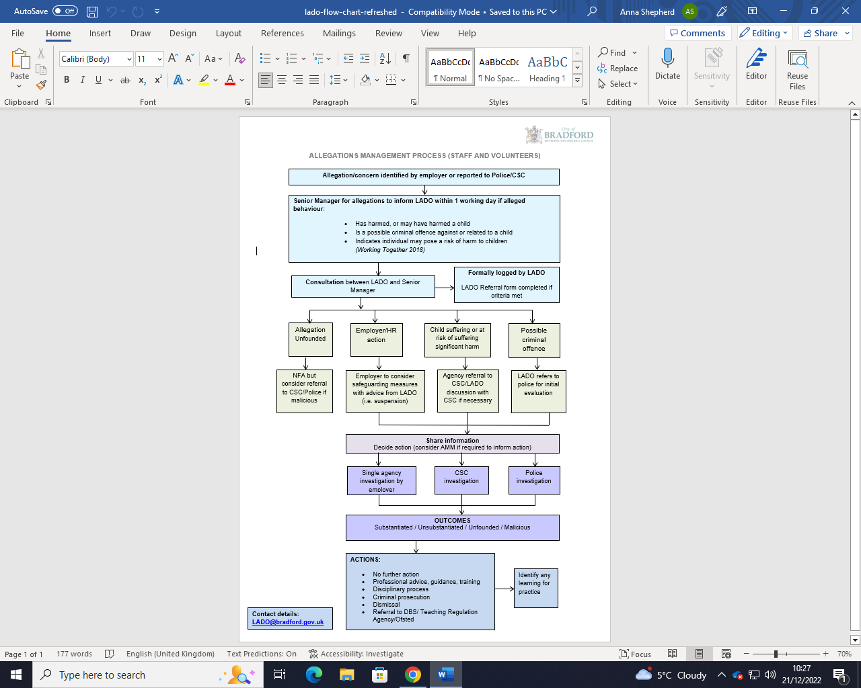
https://www.saferbradford.co.uk/resources/childrens/allegations-management-and-safer-recruitment/?zoom_highlight=LADO
Signature - 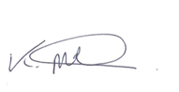 Signature Chair – 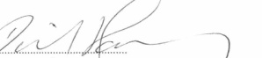
Created September 2013 | Approved by the board | Updated AUGUST 2019
Updated 2021 | Updated Dec 2022 agreed by chair Jan 2023 | Updated Oct 2023  Reviewed Jan 2025  Reviewed Aug 2025

