**Joint Activities & Motor Education Service**

**Safeguarding Adults**

Contents

Document Aims 4

Making safeguarding personal 5

6 Safeguarding Principles 6

Types of Abuse, Neglect and other Considerations 7

Who Might Commit Abuse 12

Roles and Responsibilities 13

Types of Enquiries or Investigations 17

Safeguarding Children and Young People 18

Mental Capacity and Decision Making 18

Involving the Adult at Risk 20

Information Sharing 20

Equality and Diversity 22

Duty of Care 22

Training 22

Raising Awareness of Safeguarding 22

Procedure Flow charts ` 24

Raising a Concern? 24

Whistleblowing 26

Codes of Practice 27

Communication with the Community and Media 27

This document operates as part of the wider JAMES portfolio of policies and procedures.

JAMES mission is;

***“To provide an effective, caring and understanding environment where young people and families can overcome disadvantage and lack of provision to achieve their full potential in life”***

In achieving this JAMES understands we have a critical role to ensure that all who access our services are kept safe. Our responsibility extends to others operating within the organisation, including all; staff, volunteers, trustees and student placements.

The Voluntary Sector are taking on increasing service delivery to those facing disadvantage, where as a result JAMES promotion of welfare and wellbeing will be part of a multi-agency response in Bradford District; where everyone has a responsibility.

The young people, families and all who participate at JAMES, have the right to protection, regardless of age, gender, race, culture, disability or other characteristic. At JAMES we respect all who engage with us; supporting them to overcome individual barriers, giving them the confidence and ability to sustain positive changes in their lives. We work to build an effective, caring and understanding environment, creating a culture of security, where people feel valued and listened to. Those that engage with JAMES drive our programmes, creating services which reflect the needs and resilience of our communities.

JAMES is committed to safer recruitment and the guidelines within this document are for all staff and volunteers to follow when faced with safeguarding and child protection situations. We all have a responsibility and need to take an active role in supporting young people and families, ensuring we do not miss an opportunity to make a positive difference.

This document will be available for inspection and reference at all times, as well as being accessible on our website, at JAMES sites, for all staff and volunteers and as part of our induction process.

JAMES Management Team

# Document Aims:

The Care Act 2014 has now placed safeguarding adults on a statutory footing with new duties and responsibilities.

This document provides guidelines to help ensure that

a) Everyone has the right to live their life free from violence, fear and abuse

b) All adults have the right to be protected from harm and exploitation

c) All adults have the right to independence, which involves a degree of risk.

JAMES supports the JOINT MULTI-AGENCY SAFEGUARDING ADULTS POLICY & PROCEDURES and the Bradford Safeguarding Adults Board which has informed this document:

<https://saferbradford.co.uk/adults/>

JAMES work with, support and sometimes lead different agencies to enable the most appropriate form of intervention to take place. This policy aims to outline this role, the procedures that staff should take and guidance on issues related to safeguarding, it also provides information. It is not exhaustive. All staff should put the needs and safety of our participants at the centre of any decision they need to take. We all have a responsibility to not miss an opportunity to keep JAMES service users safe.

**What is Safeguarding**

Adult safeguarding means protecting a person’s rights to live in safety, free from abuse and neglect. An adult at risk is any person who is aged 18 years or over and at risk of abuse or neglect because of their needs for care and support. Where someone is over 18 but still receiving children’s services and a safeguarding issue is raised, the matter should be dealt with as a matter of course by the adult safeguarding team.

Safeguarding focuses on people who, because of their vulnerable situation, are least able to protect themselves from harm. At times it is not just the people with decision making impairment but also adults with no underlying cognitive impairment but whose physical situation, or brief period of illness, has temporarily affected their ability to protect their own interests.

It does not mean taking away their rights to make choices and to decide how to live their lives. People are entitled to decide how they manage their safety provided they have the mental capacity to make this decision and others are not also at risk. Abuse is the misuse of power, trust, respect, control and/or authority; it violates a person’s human and civil rights.

**An adult at risk – definition**   
Is a person (18 and over) who has care and support needs (irrespective of whether such needs are being formally met) **and**; is experiencing, or is at risk of abuse or neglect **and**; is unable to protect themselves because of their care and support needs.

**Making safeguarding personal** (MSP)  
  
MSP means that safeguarding:

* + *Is person led;*
  + *Is outcome focused;*
  + *Enhances involvement, choice and control.*

It is important that conversations are had with the person to ensure their desired outcomes are identified and that safeguarding interventions are introduced to meet such outcomes. These outcomes should be measured at the end of the intervention. MSP supports personalisation, putting the person in control of shaping their intervention, this removes the new need to follow a process.  
  
The key focus is on developing a real understanding of what people wish to achieve. This includes agreeing, negotiating and recording their desired outcomes, working out with them (and their representatives or advocates if they lack capacity) how best those outcomes might be reached, and the extent to which desired outcomes have been realised at the end point.

# 6 Safeguarding Principles:

# All staff have the responsibility to follow the six safeguarding principles enshrined within The Care Act 2014:

# Principle 1 Empowerment – Personalisation and the presumption of person-led decisions and informed consent.

# *‘I am asked what I want as the outcomes from the safeguarding process and these directly inform what happens’*

# Principle 2 Prevention – It is better to take action before harm occurs.

# *‘I receive clear and simple information about what abuse is, how to recognise the signs and what I can do to seek help’*

# Principle 3 Proportionality – Proportionate and least intrusive response appropriate to the risk presented.

# *‘I am sure that the professionals will work for my best interests as I see them and they will only get involved as needed’*

# Principle 4 Protection – Support and representation for those in greatest need

# *‘I get help and support to report abuse. I get help to take part in the safeguarding process to the extent to which I want and to which I am able’*

# Principle 5 Partnerships – Local solutions through services working with their communities. Communities have a part to play in preventing, detecting and reporting neglect and abuse.

# *‘I know that staff treat any personal and sensitive information in confidence, only sharing what is helpful and necessary. I am confident that professionals will work together to get the best result for me’*

# Principle 6 Accountability – Accountability and transparency in delivering safeguarding.

# *‘I understand the role of everyone involved in my life’*

# In developing this policy JAMES is committed to

# a) Ensuring that there is a consistent and effective response to any concerns, allegations or disclosures of abuse

# b) Supporting staff in reporting and investigating incidents of adult abuse

# c) Ensuring that staff and volunteers have the knowledge and understanding about adult protection and receive training on implementing safeguarding procedures

# d) Working in partnership with other organisations

# e) Monitoring and evaluating our own practices

# f) Contributing towards inter-agency adult protection investigations and risk management plans

# g) Encouraging staff and members of the public to report abuse or suspicions of abuse

# h) Working towards creating safer services

# j) Making safeguarding personal: promoting and empowering JAMES service users

**Types of Abuse, Neglect and other Considerations**

# How do You Know When Abuse or Risk May Exist?

This guidance should not limit what constitutes abuse or neglect. The specific circumstances of an individual case should always be considered. The following is a list of some forms of abuse, but it is not exhaustive.

JAMES staff have a role that is about building positive relationships, which often means they are well placed to notice any outward signs of abuse and/or any significant changes in behaviour.

If you have any concerns about an adult whom you feel may be showing signs of risk, or abuse, yet are uncertain, use the steps outlined in these guidelines and speak to Kevin Metcalfe; Designated Safeguarding Officer (DSO).

**Discriminatory abuse** – Discrimination on the grounds of race, faith or religion, age, disability, gender, sexual orientation and political views, along with racist, sexist, homophobic or ageist comments or jokes, or comments and jokes based on a person’s disability or any other form of harassment, slur or similar treatment. Excluding a person from activities on the basis they are ‘not liked’ is also discriminatory abuse.

**Domestic abuse** - The cross-government definition of domestic violence and abuse is: any incident or pattern of incidents of controlling, coercive, threatening behaviour, violence or abuse between people aged 16 or over who are, or have been, intimate partners or family members regardless of gender or sexuality. The abuse can encompass but it is not limited to:

* psychological
* sexual (including female genital mutilation)
* financial
* emotional
* forced marriage
* honour-based violence

A new offence of coercive and controlling behaviour in intimate and familial relationships was introduced in the Serious Crime Act 2015. Serious Crime Act 2015 - Legislation.gov.uk The offence imposes a maximum five years imprisonment. The offence closes the gap in the law around patterns of coercive and controlling behaviour during a relationship between intimate partners, former partners who still live together, or family members, sending a clear message that it is wrong to violate the trust of those closest to you, providing better protection to victims experiencing continuous abuse allowing for earlier identification, intervention and prevention.

In relation to high risk domestic violence cases a Multi-Agency Risk Assessment Conference (MARAC) meeting may be held. MARAC meetings include representatives of local police, probation, health, children and safeguarding adults, housing practitioners, substance misuse services, Independent Domestic Violence Advisers (IDVAs) and other specialists from statutory and voluntary sectors.

The aims of a MARAC are as follows:

· to safeguard adult victims who are at high risk of future domestic violence and abuse

· to make links with other public protection arrangements in relation to children, the perpetrator and people at risk

· to safeguard agency staff, and

· to work towards addressing and managing the behaviour of the perpetrator

Safeguarding adults services and domestic violence services need to work together to ensure the safety, protection, needs and wishes of the person at risk are met.

Domestic violence can be reported to the police. If the person has needs for care and support, and is unable to protect themselves as a result, a safeguarding concern should be raised. The police and safeguarding adults services will both work with domestic violence services for that area.

**Modern slavery** - Slavery, servitude and forced or compulsory labour. A person commits an offence if:

The person holds another person in slavery or servitude and the circumstances are such that the person knows or ought to know that the other person is held in slavery or servitude, or

The person requires another person to perform forced or compulsory labour and the circumstances are such that the person knows or ought to know that the other person is being required to perform forced or compulsory labour. There are many different characteristics that distinguish slavery from other human rights violations, however only one needs to be present for slavery to exist. Someone is in slavery if they are:

* Forced to work – through mental or physical threat
* Owned or controlled by an “employer”, usually through mental or physical abuse or the threat of abuse
* Dehumanised, treated as a commodity or bought and sold as property
* Physically constrained or has restrictions placed on his/her freedom of movement
* Subject to human trafficking

Contemporary slavery takes various forms and affects people of all ages, gender and race. Adults who are enslaved are not always subject to human trafficking. Recent court cases have found homeless adults promised paid work opportunities enslaved and forced to work and live in dehumanising conditions, and adults with a learning difficulty restricted in their movements and threatened to hand over their finances and work for no gains. From 1 November 2015, specified public authorities have a duty to notify the Secretary of State of any person identified in England and Wales as a suspected victim of slavery or human trafficking, under Section 52 Modern Slavery Act 2015.

**Neglect and acts of omission** - Ignoring medical, emotional or physical care needs, failure to provide access to appropriate health, social care or educational services, and the withholding of the necessities of life such as medication, adequate nutrition and heating. Neglect also includes a failure to intervene in situations that are dangerous to the person concerned or to others, particularly when the person lacks the mental capacity to assess risk for themselves

**Organisational abuse** - Is the mistreatment, abuse or neglect of an adult by a regime or people in a setting or service where the adult lives or that they use. Such abuse violates the person’s dignity and represents a lack of respect for their human rights.

**Physical abuse** - Assault, hitting, slapping, pushing, misuse of medication, restraint or inappropriate physical sanctions

**Emotional/ Psychological abuse** - Emotional abuse, threats of harm or abandonment, deprivation of contact, humiliation, blaming, controlling, intimidation, coercion, harassment, verbal abuse, cyber bullying, isolation or unreasonable and unjustified withdrawal of services or supportive networks.

**Sexual abuse** - Rape, indecent exposure, sexual harassment, inappropriate looking or touching, sexual teasing or innuendo, sexual photography, subjection to pornography or witnessing sexual acts and sexual assault or sexual acts to which the adult has not consented or was pressured into consenting.

**Self-neglect** - This covers a wide range of behaviour concerning a person’s personal hygiene, health or surroundings and includes behaviour such as hoarding. It should be noted that self-neglect may not prompt a section 42 enquiry. An assessment should be made on a case-by-case basis. A decision on whether a safeguarding response is needed will depend on the person’s ability to protect themselves by controlling their own behaviour. There may come a point when they are no longer able to do this, without external support.

**Financial Abuse**

Including; theft, fraud, internet scamming and coercion or misappropriation of property. Financial abuse is the main form of abuse investigated by the Office of the Public Guardian both amongst adults at risk and children. Financial recorded abuse can occur in isolation, but as research has shown, where there are other forms of abuse, there is likely to be financial abuse occurring. Although this is not always the case, everyone should also be aware of this possibility.

**Forced marriage**

Forced marriage is against the law and occurs when, one or both spouses do not consent to a marriage and some element of duress is involved. Duress might include both physical and/or emotional/psychological pressure. Forced marriage is recognised as an abuse against human rights and will also constitute abuse within the context of this Multi-Agency Safeguarding Adults Policy and Procedure if the person is also an adult at risk.

The Forced Marriage Unit is a joint initiative between the Home Office and the Foreign and Commonwealth Office providing specialist advice and guidance. The guidance recommends forced marriage of an adult at risk, should be dealt with within the safeguarding adults procedure. The *One Chance Rule* is that sometimes there will only be one chance to help a person facing forced marriage, hence reference should be made with urgency to the Multi-Agency Practice Guidelines listed above.

The police should always be contacted for advice in relation to suspicions or concerns about forced marriage.

In addition, the Forced Marriage Unit provides a confidential advice and assistance for**:**

* those who have been forced into marriage
* those at risk of being forced into marriage
* people worried about friends or relatives
* professionals working with actual or potential victims of forced marriage

Forced marriage should be reported to the police. If the person has needs for care and support, and is unable to protect themselves as a result, a safeguarding concern should also be raised.

The Forced Marriage Unit website provides a wealth of information and guidance

www.fco.gov.uk/forcedmarriage, together with a helpline: 020 7008 0151

**Honour-based violence**

So-called 'honour-based violence’ is a crime or incident, which has or may have been, committed to protect or defend the perceived honour of the family and/or community.

Honour-based violence can take many forms, it is used to control behaviour within families to protect perceived cultural and religious beliefs and/or honour. Examples may include murder, fear of or actual forced marriage, domestic violence, sexual abuse, false imprisonment, threats to kill, assault, harassment and forced abortion. This list is not exhaustive.

Women are predominantly (but not exclusively) the victims and the violence is often committed with a degree of collusion from family members and/or the community.

Honour-based violence is a crime and should be reported to the police. If the person has needs for care and support, and is unable to protect themselves as a result, a safeguarding concern should be raised.

**Hate crime**

Hate crime is taken to mean any crime where the perpetrator’s prejudice against any identifiable group of people is a factor in determining who is victimised. Hate crime is a form of discriminatory abuse.

Hate crimes happen because of hostility, prejudice or hatred of people due to:

* disability
* gender identity
* race, ethnicity or nationality
* religion or belief
* sexual orientation

The police and other organisations work together to ensure a robust, coordinated and timely response to situations where adults at risk become a target for hate crime. Coordinated action will aim to ensure that victims are offered support and protection and action is taken to identify and prosecute those responsible.

Hate crime should be reported to the local community safety initiative. If the person has needs for care and support, and is unable to protect themselves as a result, a safeguarding concern should also be raised. In the event that a person is at immediate risk, contact the police.

**FGM**

Female genital mutilation (FGM) is the partial or total removal of external female genitalia for non-medical reasons. It's also known as female circumcision or cutting. Religious, social or cultural reasons are sometimes given for FGM. However, FGM is child abuse. It's dangerous and a criminal offence. There are no medical reasons to carry out FGM. It doesn't enhance fertility and it doesn't make childbirth safer. It is used to control female sexuality and can cause severe and long-lasting damage to physical and emotional health. As FGM is illegal this should be reported to the Police via the 101 non-emergency number, staff need to speak to the JAMES DSO/ Deputy to ensure this takes place.

**Anti-Radicalisation and Extremism (The Prevent Duty)**

We will ensure that staff are provided with appropriate training and information to enable them to assess the risk of young people and adults being drawn into extremist ideas that are part of terrorist ideology and identify anyone who may be at risk and how to support them. We recognise that young people with low aspirations are more vulnerable to radicalisation and therefore we strive to equip our service users with confidence, self-belief, respect and tolerance as well as setting high standards and expectations for themselves.

Concerns will be discussed with the individual and their family whenever possible and with the Local Authority Prevent co-ordinator and referrals made to the Channel programme when appropriate. We recognise that during the process of radicalisation it is possible to intervene to prevent vulnerable people being radicalised.

Radicalisation is defined as the act or process of making a person more radical or favouring of extreme or fundamental changes in political, economic or social conditions. Extremism is defined by HM Government as ‘vocal or active opposition to fundamental British values, including democracy, the rule of law, individual liberty and mutual respect and tolerance of different faiths and beliefs; and/or calls for the death of members of our armed forces, whether in this country or overseas’.

All staff members are aware of these issues and have accessed training.

JAMES works within our services to promote the Fundamental British Values, tolerance and respect for diverse views, while challenging prejudice of any kind.

**Patterns of abuse**

Abuse can take place in any context. It may occur when an adult at risk lives alone or with a relative; it may also occur within nursing, residential or day care settings, within hospitals or other places previously assumed safe, or in public places.

Patterns of abuse may reflect very different dynamics, such as:

* serial abuse in which someone seeks out and ‘grooms’ individuals. Sexual abuse sometimes falls into this pattern as do some forms of financial abuse.
* long term abuse – may occur in the context of an ongoing relationship such as domestic violence between partners or generations or persistent psychological abuse
* opportunistic abuse - such as theft occurring because money or jewellery has been left lying around
* self-neglect – where a person declines support and assistance with their care and support needs impacting on their individual wellbeing.

Abuse may consist of:

* a single or repeated acts
* an act of commission or omission
* multiple acts, for example, an adult at risk may be neglected and also be financially abused

Abuse may be intentional or unintentional. A number of abusive acts are crimes and

informing the police must be a key consideration.

**Who might commit abuse?**

This procedure is relevant to all incidents of abuse, regardless of who has committed them.

Anyone might be responsible for abuse, including:

* a member of staff, a proprietor or service manager
* a member of a recognised professional group
* a service user, or other adult at risk
* a volunteer
* a member of a community group such as place of worship or social club
* a spouse, relative, member of the person’s social network or an unpaid carer
* a child, including the person’s own son or daughter
* a neighbour, member of the public or stranger; or
* a person who deliberately targets adults at risk in order to exploit them

**Abuse by ‘persons in positions of trust’**

The term ‘persons in positions of trust’ refers to an employee, volunteer, or student (paid or unpaid) who works with adults with care and support needs.

In the event a ‘person in position of trust’ is alleged to have abused an adult with care and support needs, or may pose a risk of abuse to an adult with care and support needs, it is essential that the concerns are appropriately reported and responded to within this Safeguarding Adults Policy and Procedure.

The following concerns must be reported to the local authority:

* A ‘person in a position of trust’ has or is alleged to have abused an adult with care and support needs
* A ‘person in a position of trust’ has behaved (or is alleged to have behaved) towards another adult in a way that indicates that they may pose a risk of harm to an adult with care and support needs. This could include situations involving an investigation into a criminal offence, even if the victim is not a person with care and support needs
* A ‘person in a position of trust’ has behaved (or is alleged to have behaved) towards children in a way which means they may pose a risk of harm to adults with care and support needs.

These concerns could emerge from the persons home and personal life or circumstances, as well as within their work.

The Designated Adults Safeguarding Manager (DASM) for the local authority will provide coordination and management oversight of concerns, to ensure that the risks posed by a ‘person in position of trust’ are managed appropriately. The Local Authority DASM will work with the organisation responsible for the work of the ‘person in a position of trust’ and other relevant parties to achieve this.

The organisation responsible for the employee, volunteer or student may also need to:

· Invoke its disciplinary procedure

· Undertake enquiries on behalf of the local authority, providing evidence of their findings as required.

· Consider the need to make a referral to the Disclosure and Barring Service

· Consider the need to refer the concerns to the relevant professional group under the relevant code of conduct for the profession

· Report the concerns to the police, if a crime is suspected

· Inform the Care Quality Commission (regulated care providers)

· Provide the relevant DASM(s) with demonstrable assurance that appropriate actions in relation to any identified risks are being undertaken

· Keep the relevant DASM(s) informed of actions and decision undertaken

**Abuse by children**

If an adult at risk is being abused by a child (including their own child), the response should involve the local authority children’s services and domestic violence and abuse services as appropriate, in order to respond to the risks of harm.

# Roles & Responsibilities

# What Role Does JAMES Play?

JAMES should provide an environment in which all who engage with us feel safe and are able to disclose abuse and/or circumstances in which they are or feel at risk.

JAMES is NOT an investigative agency. This means if we have concerns we will alert the relevant people using the procedures outlined below.

JAMES work in partnership with other agencies, including Social Care, the Police and Health providers. As a result JAMES staff will be part of a range of multi-agency panels and conforms to ‘Safeguarding Adults West and North Yorkshire and York Multi-Agency Policy and Procedures’ (<https://www.bradford.gov.uk/media/3927/safeguarding-adults-multi-agency-policy-and-procedures.pdf> )

**Role & Responsibilities of JAMES Trustees and staff**

All JAMES staff and trustees have the responsibility to ensure that:

* our policy and procedures are consistent with regional Multi-Agency Policy and Procedures (<https://saferbradford.co.uk/resources/adults/safeguarding-adults-policy-and-procedures/> )
* all staff and volunteers raise safeguarding concerns in-line with this document
* staff and volunteers actively contribute and participate within safeguarding Formal Enquiries and Case Conferences where appropriate.
* JAMES staff (and volunteers) will work in partnership with other agencies to ensure the safeguarding planning needs of the adult at risk are met
* information is shared between agencies in accordance with information sharing policies and protocols
* JAMES keeps its own records in relation to safeguarding concerns and how these are responded to.
* JAMES participates within Safeguarding Adults Reviews where requested by the safeguarding adults board (SAB)
* JAMES supports and empowers adults at risk to make decisions about their own lives
* staff seek further advice from the SAB to adhere to the Mental Capacity Act and Code of Practice where an adult at risk lacks mental capacity
* JAMES supports adults at risk to end abuse and to access support that enables them to cope with the impact of what has happened.
* Ensuring all staff and volunteers are made aware of Bradford safeguarding partnership procedures and where to locate them.
* Ensuring appropriate procedures are in place to deal with allegations against a member of staff or volunteer
* Ensuring that appropriate ongoing training is provided so that staff maintain knowledge of safeguarding and child protection issues and are aware of any new developments.
* Ensuring all members of staff and volunteers are made aware of the main forms of abuse and their symptoms
* Ensuring that all staff and volunteers have enhanced DBS checks.
* Implementing JAMES Health and Safety policies and procedures in order to maintain a safe and secure setting.
* Promoting anti-discriminatory and anti-oppressive practice in line with JAMES policy by providing positive role models, promoting diversity and by acknowledging and respecting the individual needs.
* Being aware of JAMES whistle blowing policy and are encouraged to raise any concerns relating to practice.
* Ensuring that they are aware that their actions, however well intentioned, may be misconstrued and therefore they must ensure that they consider, and are aware of, the implications of their actions at all times.
* New staff and volunteers are familiarised with this Adults Safeguarding document as part of their induction.

**Role of the Designated Safeguarding Officer (DSO)**

The JAMES Designated Safeguarding Officer (DSO) is Kevin Metcalfe who is responsible for ensuring that concerns of possible abuse and neglect are responded to and reported appropriately. Angie Stack is the Deputy Safeguarding Officer.

The DSO must be informed about concerns of possible abuse or neglect without delay. Where actions are needed urgently or if the DSO is unavailable, **any member of staff or volunteer** may need to raise a concern with the local authority themselves and undertake other actions required to safeguard the adult at risk.

**Gather information**

If you are made aware of safeguarding concerns or allegations, you must take them seriously however trivial they might initially seem.

You may need to gather information in order to decide whether you should raise a safeguarding concern and the most appropriate action to keep the person safe. This may involve checking relevant records, ascertaining concerns from colleagues, gathering background information, etc.

Gather only the information you need in order to make the decision about whether to raise a safeguarding concern and to keep the person safe.

Unless it might prejudice a safeguarding enquiry or a police investigation, the DSO should speak to the adult at risk to get their views about:

· what has happened

· what they want to happen now

· the desired outcomes that the adult wants

Desired outcomes are those changes that the adult at risk wants to achieve from the support they receive, such as feeling safe at home, access to community facilities, restricted or no contact with certain individuals or pursuing the matter through the criminal justice system.

**Take action to ensure the immediate safety of the adult at risk**

The DSO must consider whether there are any immediate actions they need to take in order to keep the adult, or others, safe from harm.

This involves taking actions in relation to the adult at risk and others, including:

* making an immediate evaluation of the risk to the adult at risk and others
* taking reasonable and practical steps to safeguard the adult at risk as appropriate
* liaising with the police where an immediate police presence is required or to discuss any risk management issues
* arranging any necessary emergency medical treatment; note that offences of a sexual nature will require expert advice from the police
* making sure that other service users (and staff/volunteers) are not at risk

It may also involve taking actions in relation to the person or organisation alleged to have caused harm, including:

* liaising with the police wherever possible regarding actions that may impact upon a subsequent criminal investigation, such as where the protective arrangements may forewarn the person alleged to have caused harm of an impending criminal investigation and potentially prejudice the collection of evidence
* ensuring that any staff (or volunteers) who have caused harm are not in contact with service users and others who may be at risk, for example, ‘whistle-blowers’

**Bradford**

To Raise a Safeguarding Concern

If you think an adult is at risk of abuse or you are worried that someone might be abused raise your concern at: 01274 431077 or

<https://systmonline.tpp-uk.com/Safeguarding/Home?OrgId=558423556104>

Bradford Metropolitan District Council's front door is the single point of contact to report safeguarding concerns for practitioners; 01274 431077. This also now acts as an advice line as well as a referral line.   
Operating/opening hours:  
• Monday to Thursday: 8.30am to 5pm.  
• Friday: 8.30am to 4.30pm.  
  
**Outside of opening hours this is handed over to the Emergency Duty Team (EDT)**  
  
• If your feel your concern requires an urgent out of hours response, contact the Emergency Duty Team direct on **01274 435400**.  
• If your concern is not urgent, please complete the online form.

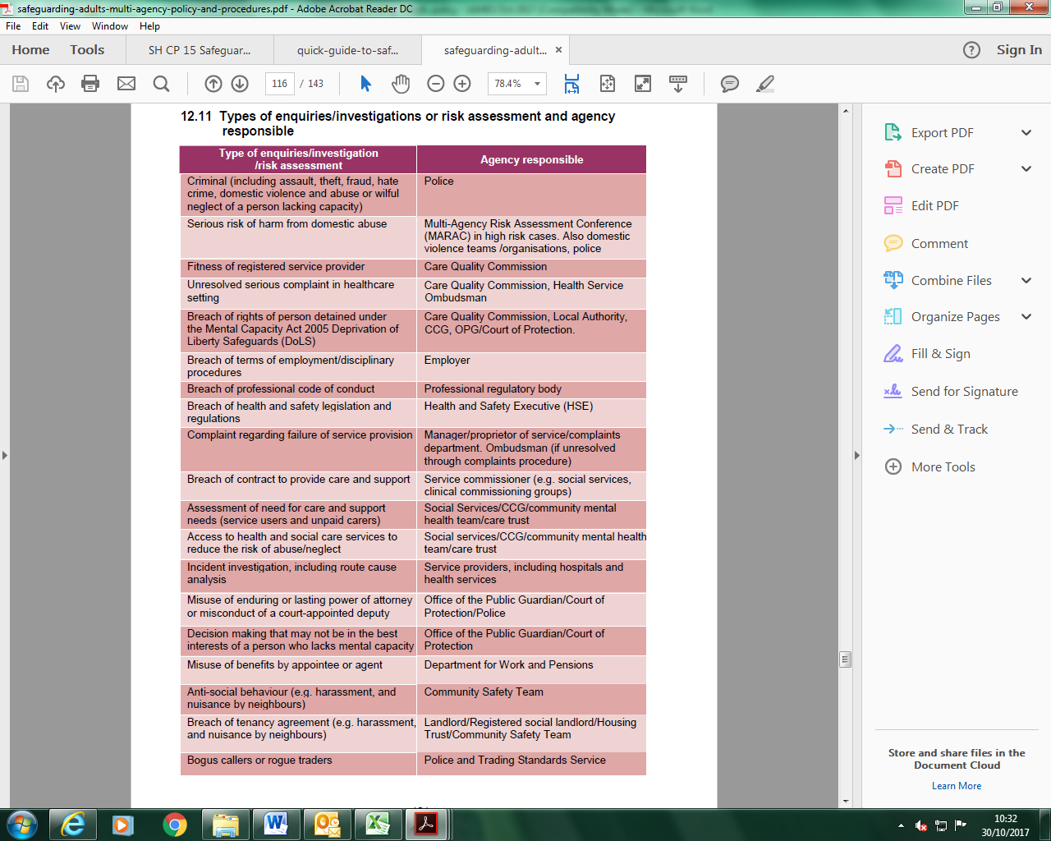

**Safeguarding children and young people**

The Children Act 1989 provides the legislative framework for agencies to take decisions on behalf of children and to take action to protect them from abuse and neglect. It is essential that JAMES staff working to safeguard adults at risk are also aware of their responsibilities to safeguard and promote the welfare of children and young people. There will be occasions when those working with adults at risk identify risks to children and young people, and occasions when safeguarding adults and safeguarding children procedure need to operate side-by-side.

This document should operate in conjunction with JAMES safeguarding and child protection document, if there are concerns about abuse or neglect of children and young people under the age of 18.

Sometimes allegations of abuse will occur with regard to a person who is approaching the age of 18. If an allegation of abuse is made before a young person turns 18, the process of safeguarding the young person would be managed under child protection procedures.

Where a young person may remain at risk after the age of 18 and they would meet the criteria of an ‘adult at risk’ at that age, representatives from adult services may need to be invited to Strategy Meetings in order to contribute to the development of protective measures and plan for the young person’s future. Once a young person turns the age of 18, protection arrangements would then be reviewed by adult services.

**Mental Capacity and Decision Making**

We make many decisions every day, often without realising. UK Law assumes that all people over the age of 16 have the ability to make their own decisions, unless it has been proved that they can’t. It also gives us the right to make any decision that we need to make and gives us the right to make our own decisions even if others consider them to be unwise.

We make so many decisions that it is easy to take this ability for granted. The Law says that to make a decision we need to:

* Understand information
* Remember it for long enough
* Think about the information
* Communicate our decision

A person’s ability to do this may be affected by things such as learning disability, dementia, mental health needs, acquired brain injury and physical ill health.   
  
Most adults have the ability to make their own decisions given the right support however, some adults with care and support needs have the experience of other people making decisions about them and for them.

Some people can only make simple decisions like which colour T-shirt to wear or can only make decisions if a lot of time is spent supporting them to understand the options. If someone has a disability that means they need support to understand or make a decision this must be provided. A small number of people cannot make any decisions. Being unable to make a decision is called “lacking mental capacity”.   
  
Mental capacity refers to the ability to make a decision at the time that decision is needed. A person’s mental capacity can change. If it is safe/possible to wait until they are able to be involved in decision making or to make the decision themselves.  
  
For example:

* A person with epilepsy may not be able to make a decision following a seizure.
* Someone who is anxious may not be able to make a decision at that point.
* A person may not be able to respond as quickly if they have just taken some medication that causes fatigue.

Mental Capacity is important for safeguarding for several reasons.  
  
Not being allowed to make decisions one is capable of making is abuse. For example, a disabled adult may want to take part in an activity but their parent who is their carer won’t allow them to and will not provide the support they would need. Conversely the adult may not seem to be benefiting from an activity other people are insisting they do.  
  
Another situation is where an adult is being abused and they are scared of the consequences of going against the views of the person abusing them. It is recognised in the law as coercion and a person can be seen not to have mental capacity because they cannot make ‘free and informed decisions’.  
  
Mental Capacity must also be considered when we believe abuse or neglect might be taking place. It is important to make sure an ‘adult at risk’ has choices in the actions taken to safeguard them, including whether or not they want other people informed about what has happened, however, in some situations the adult may not have the mental capacity to understand the choice or to tell you their views.   
  
Each home nation has legislation that describes when and how we can make decisions for people who are unable to make decisions for themselves. The principles are the same.

* We can only make decisions for other people if they cannot do that for themselves at the time the decision is needed.
* If the decision can wait, wait – e.g. to get help to help the person make their decision or until they can make it themselves.
* If we have to make a decision for someone else then we must make the decision in their best interests (for their benefit) and take into account what we know about their preferences and wishes.
* If the action we are taking to keep people safe will restrict them then we must think of the way to do that which restricts to their freedom and rights as little as possible.

Many potential difficulties with making decisions can be overcome with preparation. A person needing support to help them make decisions whilst taking part in a sports organisation will ordinarily be accompanied by someone e.g. a family member or formal carer whose role includes supporting them to make decisions.   
  
It is good practice to get as much information about the person as possible. Some people with care and support needs will have a ‘One page profile’ or a ‘This is me’ document that describes important things about them. Some of those things will be about how to support the person, their routines, food and drink choices etc. but will also include things they like and don’t like doing. It’s also important to have an agreement with the person who has enrolled the adult in the sports activity about how different types of decisions will be made on a day to day basis.   
  
If a person who has a lot of difficulty making their own decisions is thought to be being abused or neglected you will need to refer the situation to the Local Authority, and this should result in health or social care professionals making an assessment of mental capacity and/or getting the person the support they need to make decisions.

There may be times when a sporting organisation needs to make decisions on behalf of an individual in an emergency. Decisions taken in order to safeguard an adult who cannot make the decision for themselves could include:

* Sharing information about safeguarding concerns with people that can help protect them.
* Stopping them being in contact with the person causing harm.

**Involving the adult at risk**

Adults at risk need to be able to make informed decisions about situations in their own lives.

This includes having this document explained to them so that they know what to expect and can say how they would wish to be involved. The adult at risk should be central throughout the safeguarding adult procedure, be supported to make decisions relating to their own welfare, have opportunity to review enquiry reports and findings, and decide about their Safeguarding Plans. Sometimes consideration for the safety and welfare of others will need to be balanced with the wishes and views of the adult at risk.

In order to be fully involved, the adult at risk may need support in a variety of ways such as the help of a family member or friend, a language interpreter or other communication assistance.

Where a person has mental capacity to make decisions, the role of professionals is to support them to make informed decisions throughout the safeguarding adults procedure. If the person has a ‘substantial difficulty’ in participating, and has no one who can support and represent them other than in a professional capacity, then an independent advocate must be arranged where it is appropriate and proportionate to do so. The Independent Advocate’s role will be to support the person to be fully involved and participate as they would wish within the safeguarding procedure.

Where a person lacks the mental capacity, any decisions required will need to be in their best interests, involving them to the full extent possible, and taking their views, wishes, beliefs and values into account. If the adult does not have an appropriate person to represent and support them an Independent Mental Capacity Advocate must be considered.

Throughout the response to the safeguarding adults concern, due regard should be given to issues of equality and diversity, and accessibility issues.

**Information sharing**

Information sharing between organisations is essential to safeguard adults at risk of abuse, neglect and exploitation. Decisions about what information is shared and with whom will be taken on a case-by-case basis. Whether information is shared with or without the consent of the adult at risk, the information shared should be:

* necessary for the purpose for which it is being shared
* shared only with those who have a need for it
* be accurate and up to date
* be shared in a timely fashion
* be shared accurately
* be shared securely

There are only a limited number of circumstances where it would be acceptable not to share information pertinent to safeguarding with relevant safeguarding partners. These would be where the person involved has the mental capacity to make the decision and does not want their information shared AND:

* nobody else is at risk
* no serious crime has been or may be committed
* the alleged abuser has no care and support needs
* no staff are implicated
* no coercion or duress is suspected
* the public interest served by disclosure does not outweigh the public interest served by protecting confidentiality
* the risk is not high enough to warrant a multi-agency risk assessment conference referral
* no other legal authority has requested the information.

If there is reluctance from one partner to share information on a safeguarding concern the matter should be referred to the Bradford Safeguarding Adults Board.

Additional information can be obtained from HM Government (2018) – ‘Information Sharing’ <https://assets.publishing.service.gov.uk/government/uploads/system/uploads/attachment_data/file/721581/Information_sharing_advice_practitioners_safeguarding_services.pdf>

**Undertaking safeguarding responses without consent**

Consent to support through the safeguarding adults procedure is important, but not the only consideration. Sometimes it will be necessary to act contrary to a person’s expressed wishes, for example:

* the adult lacks mental capacity to consent and a decision is made to take actions in the adult’s best interests (Mental Capacity Act 2005)
* the adult is subject to coercion or undue influence, to the extent that they are unable to give consent. Legal advice may be required

Public interest considerations involve balancing the rights of the individual to privacy with the rights of others to protection. It may be necessary to act contrary to the adult’s expressed wishes in order to safeguard others, for example:

* other adults are at risk from the person or organisation alleged to be causing harm
* the concern is about organisational or systemic abuse
* the allegation or concern relates to the conduct of an employee or volunteer within an organisation providing services to adults at risk.
* the abuse or neglect has occurred on property owned or managed by an organisation with a responsibility to provide care and support

Actions may also be required in the person’s vital interests (to prevent serious harm or distress or life- threatening situations). Where a person with mental capacity declines support within this procedure, and thereby places themselves at risk of serious harm, advice may be required from your line manager, and should always be sought if the risk is life threatening. Legal advice may also be required. It may be appropriate to explore an alternative process to provide support.

**Equality and diversity**

It is every person’s human right to live a life free from abuse and neglect. Every adult at risk has an equal right to support and protection within this procedure regardless of their individual differences or circumstances.

This document applies equally to:

* all adults at risk as defined within this policy
* all agencies
* all forms of abuse

Throughout safeguarding adults due regard must be given to individual differences, including age, gender reassignment, disability, religion or belief, sex, sexual orientation, race or racial group, caring responsibilities, class, culture, language, pregnancy and marital or civil partnership status.

**Duty of care**

Everyone has a clear moral and/or professional responsibility to prevent or act on incidents or concerns of abuse. A duty of care to adults at risk is fulfilled when all the acts reasonably expected of a person in their role have been carried out with appropriate care, attention and prudence. Duty of care will involve actions to keep a person safe but will also include respecting the person’s wishes and protecting and respecting their rights. The nature of an individual’s duty of care will vary according to their role. In all cases however, it will involve taking allegations or concerns seriously, and owning one’s responsibilities to safeguard adults at risk.

**Training**

All JAMES staff and volunteers will attend training at least every three years. The DSO will undertake training every two years in order for her to fulfil her role. All staff will undertake Prevent Awareness training. The DSO will be able to provide advice and support to members of staff on protecting children from the risk of radicalisation. Most full-time staff will be trained in First Aid.

**Raising Awareness of Safeguarding**

JAMES is committed to raising awareness of safeguarding and child protection and to equipping young people and families with the skills needed to keep them safe. It aims to do this by:

* Ensuring staff have access to appropriate training and resources.
* Including opportunities in the curriculum and our programmes that will help young people and families to develop skills they need to recognise and stay safe from abuse.
* Supporting young people and families to learn about online safety.
* Providing opportunities for outside agencies to work alongside our young people and families
* Ensuring that young people and families know what to do if they have worries or concerns
* Providing young people and families with the opportunity to share their worries or concerns via a range of mediums

**PROCEDURE**

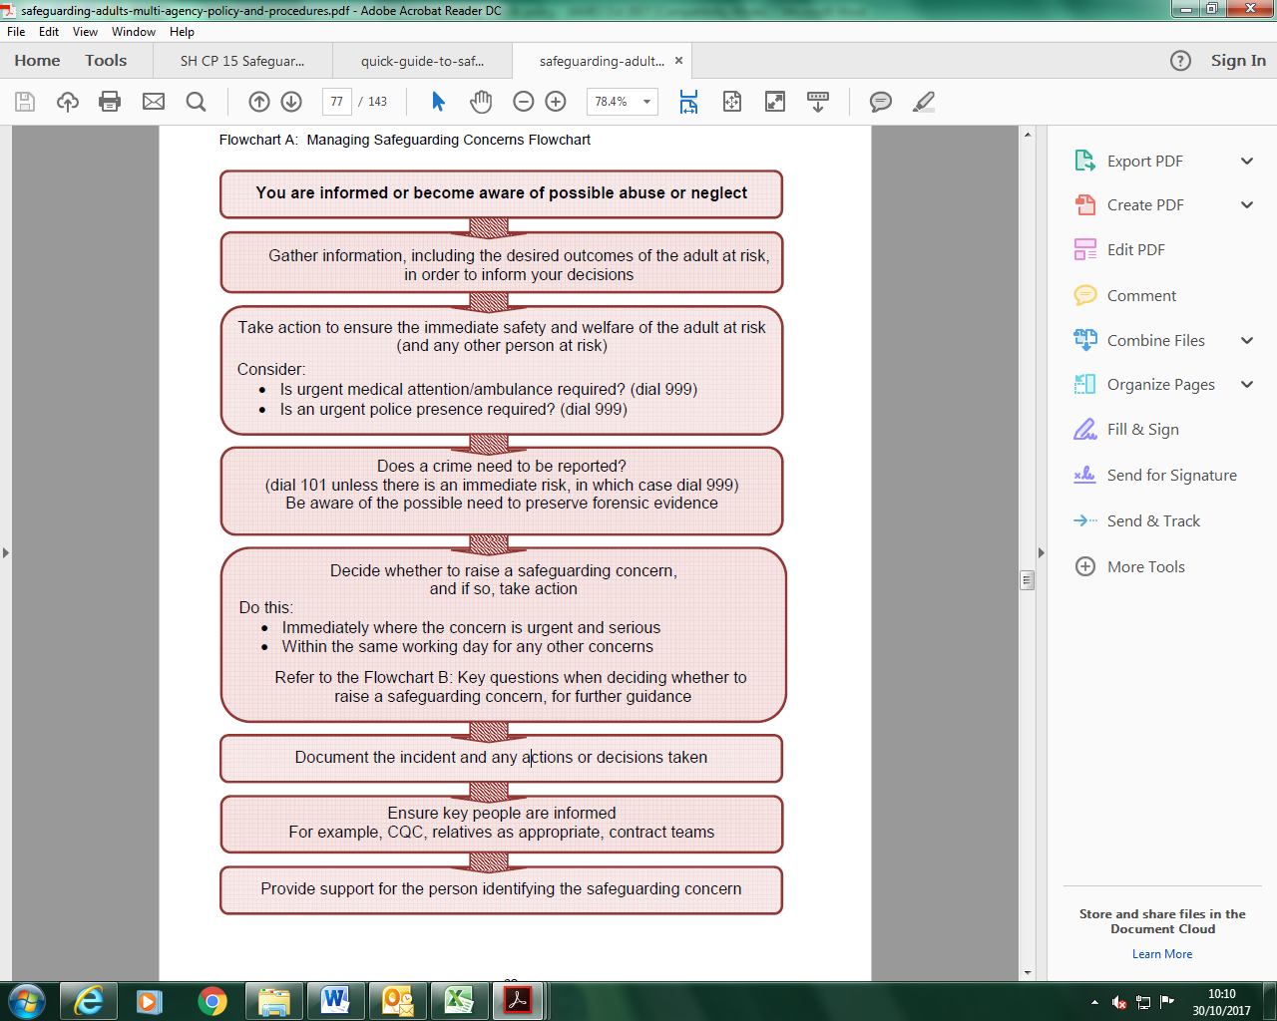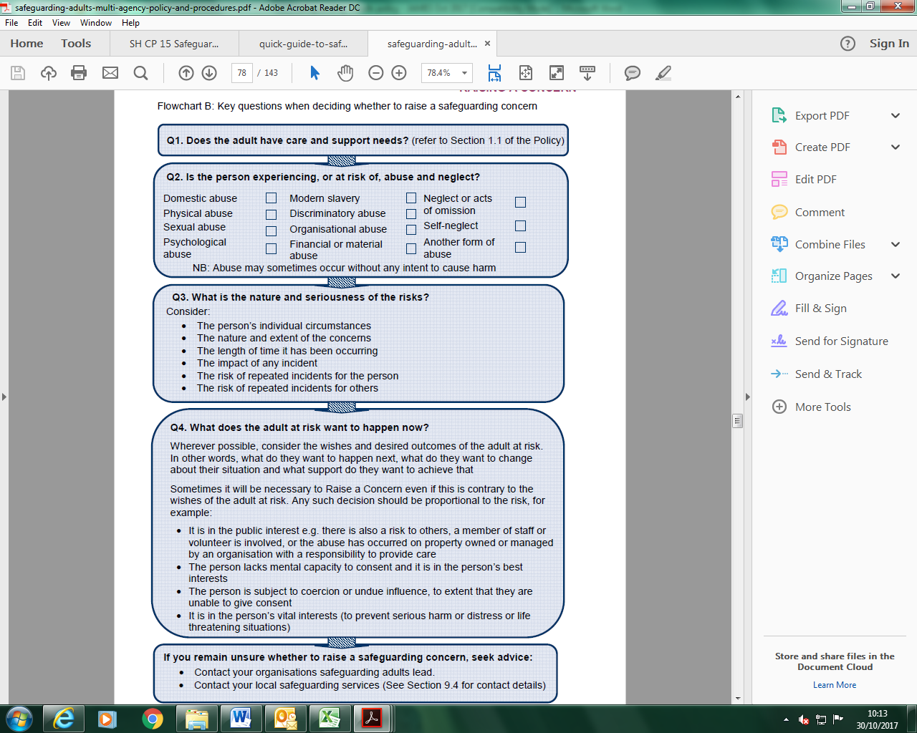

**Raising a Concern?**

Any person who has concerns that someone who has, or may have care and support needs is experiencing, or is at risk of abuse and neglect, can raise their concerns with the local authority.

This means that the adult experiencing abuse or neglect can raise their concerns themselves, but so can their friends, family members, unpaid carers, other members of the public, paid carers, professionals and organisations.

A concern may be:

* something the adult at risk has disclosed to you
* something you have been told by a colleague, a friend, relative or the carer for the adult at risk, or someone else
* something you have witnessed for yourself, for example changes in the person’s behaviour, or how the adult at risk is being treated by someone else

Wherever possible, involve the adult at risk in decisions about raising a safeguarding concern. Try and talk to the person about what the person wants to change about their situation, and what support they want to achieve that.

There are occasions when you may need to raise a concern without the person’s consent, for example:

It is in the public interest, for example,

* there is a risk to other ‘adults at risk’, or
* the concern is about organisational or systemic abuse, or
* the concern or allegation of abuse relates to the conduct of an employee or volunteer within an organisation providing services to adults at risk, or
* the abuse or neglect has occurred on property owned or managed by an organisation with a responsibility to provide care
* the person lacks mental capacity to consent and a decision is made to raise a safeguarding concern in the person’s ‘best interests’ (Mental Capacity Act 2005)
* a person is subject to coercion or undue influence, to the extent that they are unable to give consent
* it is in the adult’s vital interests (to prevent serious harm or distress or life threatening situations)

All raised safeguarding concerns will have been discussed and agreed with the DSO or another Line Manager at the earliest opportunity.

Where possible, take action to ensure the safety of the adult at risk. You may also need to inform the police (if a crime has taken place or is taking place) or seek medical attention in an emergency.

If a person discloses abuse to you directly, use the following principles to respond:

· Assure them that you are taking the concerns seriously

· Do not be judgemental or jump to conclusions

· Listen carefully to what they are telling you, stay calm, get as clear a picture as you

can. Use open-ended questions

· Do not start to investigate or ask detailed or probing questions

· Explain that you have a duty to tell your manager or designated officer

· Reassure the person that they will be involved in decisions about them

If the concerns relate to the DSO, inform another member of the Management Team.

The DSO is the person who is responsible for:

* deciding whether to raise a safeguarding concern with the local authority
* taking immediate actions, wherever possible, to ensure the adult at risk is safe from abuse or neglect

However, where a situation is urgent or serious, **any member of staff (or volunteer)** may need to undertake these actions.

**In an emergency or out of hours**

When dealing with an incident that involves the abuse of an adult at risk, staff may need to call the police and/or ambulance (dial 999), if for example:

* someone is alleging that they have been sexually assaulted
* someone has been injured as a result of a physical assault
* an allegation is made regarding a recent incident of theft
* the person alleged to have caused harm needs to be removed
* the person alleged to have caused harm is still believed to be near the premises
* there is reason to believe that a crime is in progress
* there is likely to be evidence that needs to be preserved, in the case of physical or, sexual assault the police will be able to arrange for medical evidence to be collected

This list is by no means exhaustive.

If the police do not need to be contacted but you still have immediate concerns and it is out of normal working hours, the local authority ‘emergency duty team’ can be contacted

To Raise a Safeguarding Concern

If you think an adult is at risk of abuse or you are worried that someone might be abused raise your concern at:

<https://systmonline.tpp-uk.com/Safeguarding/Home?OrgId=558423556104>

If you are not sure whether a child is at risk, you can call and discuss the circumstances. Bradford Children’s Services now has a dedicated practitioners’ advice and referral contact number.

Call 01274 433999 if you want to seek support and/or raise a concern about a child or a young person.

Opening hours:

Monday to Thursday 8.30am to 5.00pm  
Fridays 8.30am to 4.30pm

**Out of office hours**

Our Emergency Duty Team will continue to take emergency out of hours calls on 01274 431010.

**Whistle-blowing – Public Interest Disclosure Act 1998**

Members of staff working within an organisation may become aware of safeguarding

concerns or allegations but be concerned about the impact on their employment if they were to report them.

Where people have these concerns, they should refer to the JAMES “Whistle-blowing” Policy. The policy is so named, because it provides advice in relation to those circumstances when an employee is protected for reporting concerns.

For further information and advice, the following services are available:

· Mencap: www.mencap.org.uk/organisations/whistleblowing-helpline

· Care Quality Commission: www.cqc.org.uk/contact-us

· Public Concern at Work: www.pcaw.org.uk

# Codes of Practice For the purposes of this document, the following issues have been highlighted.

**Staff**

At no time is any non-approved adult to have access to JAMES service users without constant supervision from an approved member of staff. NB. 'Approved' means an adult who has been cleared in accordance with DBS. Volunteers must be cleared in accordance with all the procedures required for the appointment of paid staff.

Regular team meetings and sessional briefings should be held to clarify safeguarding roles and responsibilities and to ensure that all work is delivered proactively and reactively.

**DBS Checks**

Any employee or volunteer whose DBS check is considered unsuitable will have the right to put forward a reason/account of the incident/incidents in question.

If a potential employee/volunteer fails to pre-notify JAMES of any historical incidents that show up on the DBS check then their employment will be subject to review. Once all information has been gathered, regarding any DBS recordings, the Management Team will make an informed judgement, taking into account the nature of any incident and the age of the person when this happened.

No one will be considered with a History of:

* Offences against children

# Allegations against staff – see JAMES Allegations Policy

# Communication with the community and media

Under no circumstances should any member of JAMES staff respond to queries from the public and/or the media. All such queries will be dealt with through the Management Team. In the event that you are contacted please record the following details about the person who has contacted you:

* Name •Telephone number
* Organisation •Deadline
* Their line of enquiry/questions
* Tell them the matter will be looked into and that someone will call them back shortly. Then pass all this information to a member of the Management Team.