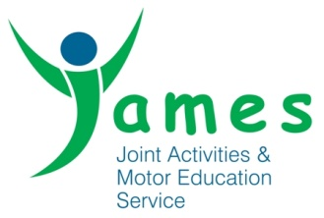 **Behaviour Policy**

Behaviour is the way we act around and respond to people, our surroundings and situations we find ourselves in.

This policy is to set guidelines for young people’s behaviour whilst on any JAMES programme and at any base, but also any behaviour that may have an impact or affect on JAMES as an organisation or it’s staff team.

We hope that this policy will encourage young people to act appropriate and in a manner that supports them in achieving their potential. This policy also helps JAMES to ensure young people are safe and protected whilst on our programmes.

What JAMES will do

* Provide positive role models for our young people that will act and behave in a manner that will set a good example to our young people.
* Teach our young people core values such as respect, honesty, integrity and responsibility.
* Ensure staff who are not setting a positive example are subject to discipline procedures.
* Provide a safe and protective environment where young people can address any personal barriers to learning or personal issues.
* Inform young people and parents/ guardians of whistle blowing and complaints procedures as part of the induction for every young person.
* Ensure JAMES and its staff team promotes equal opportunities.
* Create behaviour contracts for young people when required to support improvement.
* Log and record any behaviour concerns daily– on a weekly basis negative behaviour is monitored and communication is made with parents/ guardians, via phone call, letters or emails. If there are no negative behaviour logs then a positive letter/email is sent to parents/ guardians. End of term graphs depicting behaviour improvements are created and provide further opportunities for young people to reflect and learn from their behaviour.
* Communicate with referrers and parents about incidents or concerns.
* Staff will not physically intervene or restrain young people, except as a last resort where all other strategies have failed and where staff or any service users are at risk.

What do we expect from our young people?

* Treat others with respect
* Speak appropriately to others
* Understand other peoples needs
* Respect the environment
* Honesty
* Care for yourself and others
* Behave appropriately and safely and follow instructions from staff.
* Remain on site at all times unless we have written permission from guardian.
* Make all attempts to repair any damage caused.

We will not tolerate the following behaviour from young people within our projects

* Bullying
* Racism in any form
* Aggressive behaviour towards others (staff or young people) in a verbal or physical manner.
* Endangering the safety of young people, staff or members of the community
* Stealing or damaging property
* Inappropriate use of the internet/viewing of or bringing in any inappropriate material – this includes viewing inappropriate material on personal phones.
* Using illegal substances or any legal highs at JAMES.
* Coming onto JAMES projects/bases under the influence of illegal substances or legal highs.
* Use of phones and or other electrical equipment during sessions (unless agreed by staff – phones to be handed over to reception at the start of the day and after lunch)
* Frequently swearing, vulgarity or lewd behaviour.
* Sexual abuse or sexual harassment in any form including (but not only) skirt lifting, pulling down trousers, touching, verbal abuse, threats or intimidation.
* Play fighting.

Sanctions – Sanctions may vary depending on severity of the incident but will include some or all of the following

* Staff will encourage young people to behave appropriately
* Young person will be reminded of guidelines and acceptable behaviour
* One to one discussion
* Temporary removal from the group
* Contacting parents/guardians
* A report will be written detailing the incident – sent to referrer
* Groups or individuals missing trips/outings/activities
* Weekly letters home about negative behaviour incidents
* Staff removing items causing a concern until the end of the day
* A meeting to be arranged with parent/guardian
* Send home/Temporary suspensions/permanent exclusion

Parents or referrers are to be notified of any send homes or exclusions. Staff have authority to implement sanctions but any send homes or exclusions must be agreed with a member of the management team. Admission and removal is at the discretion of JAMES.

Rewards for good behaviour –

* Trips and outdoor activities.
* Positive progression opportunities such as apprenticeships and volunteering.
* Use of in house equipment such as Go-karts and canal barge.
* Certificates, stickers and feedback
* End of term rewards
* Letters and calls to parents/guardians
* More responsibility and input into programmes
* Hoodies and mentoring responsibilities

Legalities and rules that we are committed to following –

* All JAMES funders such as schools, councils and PRU’s have different policies in place and as an organisation we must ensure we are supporting schools/funders to follow their guidelines and behaviour policies.
* Safeguarding procedures and policies from Safer Bradford

JAMES utilises external specialist support where appropriate; such as BMDC.

What action can parents or learners take if they have any concerns?

* Any concerns or complaints, as well as compliments can be directed to the management team at head office by email [enquiries@jamesuk.org](mailto:enquiries@jamesuk.org) by phone on 01274 483075 or in person at; Lower Ground Floor, Shipley Wharf, Wharf Street, SHIPLEY, BD17 7DW

Safeguarding – All young people will complete a safeguarding form as part of their induction to ensure young people understand what safeguarding is. Staff must immediately report any safeguarding concerns to the DSL or Deputy DSL and follow the appropriate policies and procedures.

The induction also clarifies points around compliments and complaints and equal opportunities.

What we will do with this policy;

* Publish it on the website
* Ensure all young people and parents are given a copy
* Update yearly and re publish with any modifications
* Ensure it’s displayed in JAMES bases

Signature Principal - 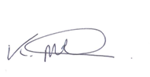 Signature Chair – 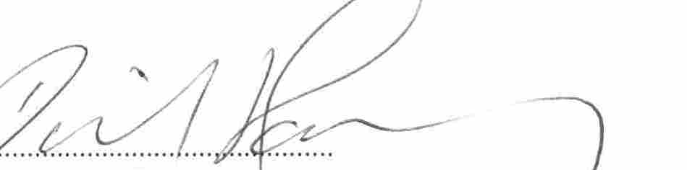

|  |  |  |
| --- | --- | --- |
| Created January 2013  Approved by the board 6/2/2013  Issue 2 | Minor changes  Minor changes  Minor changes  Minor changes  Minor changes | Dec 2019  Aug 2021  Aug 2022  Aug 2023  Sept 2024 |